Lab. 2
Linear Op-Amp Circuits

Team No. _.
Names:
____________________________________________. I.D _.

____________________________________________. I.D _.

Reference:
Floyd Thomas L., Buchla David M.: Experiments in Analog Fundamentals, A System Approach. Pearson Education, 2013.

Reading:
Floyd and Buchla, Fundamentals: A Systems Approach, Sections 6-4 through 6-6. Pearson Education, 2013.

Objectives:
After performing this experiment, you will be able to:
- Construct and test inverting and noninverting amplifiers using op-amps.
- Specify components for inverting and noninverting amplifiers using op-amps.

Materials Needed:
  - Resistors: two 1kΩ, one 10 kΩ, one 470kΩ, one 1.0MΩ
  - Two 1.0 µF capacitors
  - One 741C op-amp
  - For Further Investigation:
One 1.0kΩ potentiometer, one 100kΩ resistor, assorted resistor to test.

Summary of Theory:

One of the most important ideas in electronics incorporates the idea of feedback, where a portion of the output is returned to the input. If the return signal tends to decrease the input amplitude, it is called negative feedback. Negative feedback produces a number of desirable qualities in an amplifier, increasing its stability and its frequency response. It also allows the gain to be controlled independently of the device parameters, temperature, or other variables.
Operational amplifiers are almost always used with external, negative feedback. The feedback circuit determines the specific characteristics of the amplifier. By itself, an op-amp has an extremely high voltage gain called the open-loop gain, Aol. When negative feedback is added, the overall gain of the amplifier is determined by the feedback circuit. This gain, including the feedback circuit, is called the closed-loop gain, 𝐴𝑐𝑙.
Figure 20-1 illustrates a noninverting amplifier with negative feedback. The input is applied to the noninverting terminal and a fraction (B) of the output is returned to the inverting input by the voltage divider. The very high gain of the amplifier forces the two inputs to be very nearly the same voltage; therefore, the input voltage is across 𝑅_{𝑖}, and the output voltage is across 𝑅_{𝑖} + 𝑅_{𝑓}. The closed-loop gain of this noninverting amplifier is given as 𝐴_{𝑐𝑙(𝑁𝐼)}. The closed loop gain is the reciprocal of the feedback fraction as shown in Figure 20-1.

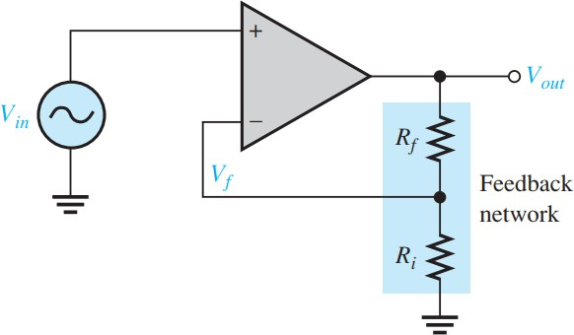
𝑓𝑒𝑒𝑑𝑏𝑎𝑐𝑘 𝑓𝑟𝑎𝑐𝑡𝑖𝑜𝑛 = 𝐵 =
𝑅_{𝑖}

𝑅_{𝑖} + 𝑅_{𝑓}

Figure 20-1
1
𝐴𝑐𝑙(𝑁𝐼) = 𝐵 =
𝑅_{𝑖} + 𝑅_{𝑓}
𝑅_{𝑖}
= 1 +
𝑅_{𝑖}
𝑅_{𝑓}

An inverting amplifier is shown in Figure 20-2. In this amplifier, the output voltage is the opposite phase to the input voltage. The noninverting input is grounded, and the input signal is applied through a resistor to the inverting terminal. A feedback resistor is connected between is the output and the inverting input. This amplifier can be analyzed by assuming the input current same as the current in the feedback resistor, Iin, = If and that the open loop gain of the amplifier is very high. From these assumptions, the closed loop gain can be calculated quite accurately ratio of the feedback resistor to the input resistor. The basic equations for the inverting amplifier are shown with Figure 20-2. The minus sign indicates inversion between the input and output. ₍₋₎ refers to the inverting input on the op-amp.
𝑉

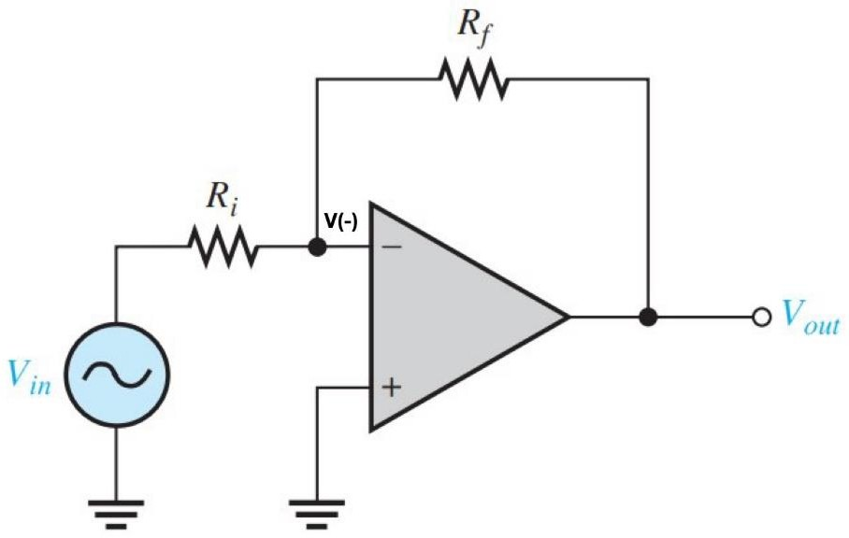
𝐼_{𝑖𝑛} = 𝐼_{𝑓}
𝐴_{𝑜𝑙} is very large, therefore.

𝑉(−)
= − 𝑉𝑜𝑢𝑡 ≅ 0
𝐴𝑜𝑙

𝑉𝑜𝑢𝑡
𝑉𝑖𝑛

𝑅_{𝑖}
𝑉𝑜𝑢𝑡
= −
𝑅_{𝑓}
𝑅_{𝑓}

Figure 20-2
𝑉𝑖𝑛
= 𝐴𝑐𝑙(𝐼) = −
𝑖
𝑅

Procedure:

- The circuit to be tested in this step is the noninverting amplifier illustrated in Figure 20-3.

  - Measure a 10kΩ resistor for 𝑅_{𝑓} and 1.0kΩ resistor for 𝑅_{𝑖}. Record the measured value of resistance in Table 20-1.
  - Using the measured resistances, compute the closed-loop gain of the noninverting amplifier. The closed-loop gain equation is given next to Figure 20-1.

  - Calculate 𝑉_{𝑜𝑢𝑡} using the computed closed-loop gain.
  - Connect the circuit shown in Figure 20-3. Set the signal generator for a 500 m𝑉_{𝑝𝑝} sinusoidal wave at 1.0kHz. The generator should have no dc offset.
  - Measure the output voltage, 𝑉_{𝑜𝑢𝑡}. Record the measured value.
  - Measure the feedback voltage at pin 2. Record the measured value.

  - Place a 1.0 MΩ test resistor in series with the generator. Measure the input resistance of the circuit, 𝑅_{𝑖𝑛}, based on the voltage drop across the test resistor. Use the voltage divider rule to indirectly find the input resistance.

Table 20-1

𝑅_{𝑓}  Measured | 𝑅_{𝑖}  Measured | 𝑉𝑖𝑛  Measured | 𝐴𝑐𝑙(𝑁𝐼)  Computed | 𝑉𝑜𝑢𝑡 Computed (pin 6) | 𝑉𝑜𝑢𝑡 Measured (pin 6) | 𝑉(−)  Measured (pin 2) | 𝑅𝑖𝑛  Measured
 |  | 500 m𝑉_{𝑝𝑝}

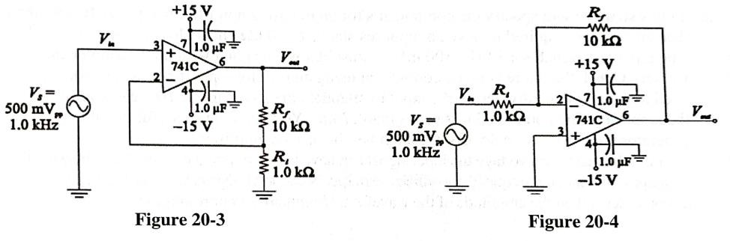

- In this step you will test an inverting amplifier. All data are to be recorded in Table 20-2. The circuit is illustrated in Figure 20-4. The close-loop gain is:
𝑅_{𝑓}
𝐴𝑐𝑙(𝐼) = −
𝑅
𝑖
  - Use the same resistors for 𝑅_{𝑓} and 𝑅_{𝑖} as in step 1. Record the measured value of resistance in Table 20-2.
  - Using the measured resistance, compute and record the closed-loop gain of the inverting amplifier.

  - Calculate the 𝑉_{𝑜𝑢𝑡} using the computed closed-loop gain.
  - Connect the circuit shown in Figure 20-4. Set the signal generator for the 500 m𝑉_{𝑝𝑝} sine wave at 1kHz. The generator should have no dc offset.
  - Measure and record the output voltage, 𝑉_{𝑜𝑢𝑡}.
  - Measure and record the output voltage at pin 2. This point is called a virtual ground because of the effect of negative feedback.

  - Place a 1.0 KΩ test resistor in series with the generated and 𝑅_{𝑖}. Measured the input resistance of the circuit, 𝑅_{𝑖𝑛}, based on the voltage drop across the test resistor. In this case, you should observe that the drop across the test resistor is about the same as the drop across 𝑅_{𝑖}.

Table 20-2

𝑅_{𝑓}  Measured | 𝑅_{𝑖}  Measured | 𝑉𝑖𝑛  Measured | 𝐴𝑐𝑙(𝑁𝐼)  Computed | 𝑉𝑜𝑢𝑡 Computed (pin 6) | 𝑉𝑜𝑢𝑡 Measured (pin 6) | 𝑉(−)  Measured (pin 2) | 𝑅𝑖𝑛  Measured
 |  | 500 m𝑉_{𝑝𝑝}

- In this step you will specify the components for an inverting amplifier using a 741C Op-Amp. The amplifier is required to have an input resistance of 10 kΩ and a closed-loop gain of – 47. The input test signal is a 1kHz, 100 m𝑉_{𝑝𝑝} sinusoidal wave signal with no dc component (offset). Check that there is no dc component using an oscilloscope. If necessary, you may need to put a voltage divider on the input to attenuate the signal to the 100 mV level.
Draw the amplifier. Then build and test your circuit.

Note: You need to be careful that the generator does not have a dc offset: remember this is a dc amplifier!

Find the maximum voltage the input signal can have before clipping occurs. Try increasing the frequency and note the frequency at which the output is distorted. Does the upper frequency response depend on the amplitude of the waveform? Summarize your results in the space provided.

Conclusion:

Evaluation and Review Questions:
- Express the gain of the amplifiers tested in steps 1 and 2 in dB.

- It was correct to talk about a virtual ground for the inverting amplifier. Why isn’t it correct to refer to a virtual ground for the noninverting amplifier?

- If 𝑅_{𝑓} = 𝑅_{𝑖} = 10𝑘Ω, what gain would you expect for:
  - A noninverting amplifier?

  - An inverting amplifier?

  - For the noninverting amplifier in Figure 20-3, if 𝑅_{𝑓} = 0 and 𝑅_{𝑖} is infinite, what is the gain?

  - What is this type of amplifier called?

- What output would you expect in the inverting amplifier of Figure 20-4 if 𝑅_{𝑓} were open?

For further investigation

An interesting application of an inverting amplifier is to use it as the basis of an ohmmeter for high value resistors. The circuit is shown in Figure 20-5. The unknown resistor, labeled 𝑅_{𝑥}, is placed between the terminals. The output voltage is proportional to the unknown resistance.
Calibrate the meter by placing a known 10 kΩ resistor in place of 𝑅_{𝑥} and adjusting the potentiometer for exactly 100 mV output. The output then represents 10mV/1000Ω . By reading the output voltage, and moving the decimal point, you can directly read resistors from several thousand ohms to over 1 MΩ.
Construct the circuit and test it using different resistors. Calibrate output voltage against resistance and compare with theory. Find the percent error for a 1MΩ resistor using a lab meter as a standard.
Summarize your results in a short report.

